**Data Exploration and Visualization**

Conducted by: Dr. Abhishek Agarwal

Date: 16-March-2021

**Home Task 2**

Amir Ali

Generate the following plots

1. **HeatMap**

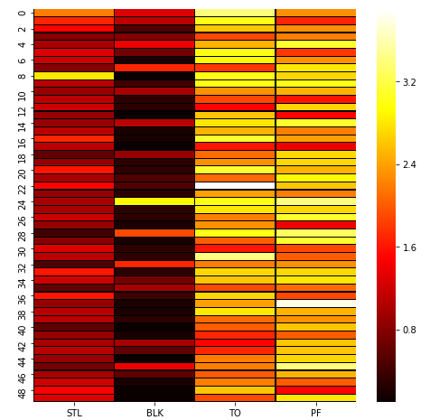

1. **Correlogram**

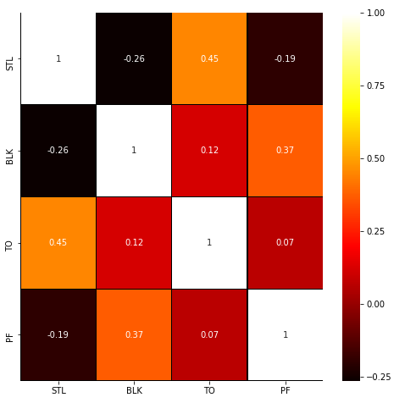

1. **3D Graph**

